## horizontal line



Recipe Box

18.07.2019

**─**

Karim Khalifa & Mohamed Elsayed

# Overview

Recipe Box is a food box delivery service. If you're just learning how to cook, haven't got the time to go to markets to grab the ingredients you need for your meal or you just love to cook. We have it delivered to your doorstep, in a box, alongside with a recipe sheet with visuals to aid you with the cooking process.

# Goals

1. Over simplify the whole process of searching for recipes online, weighing in their ingredients and go to the market with a list. Just order yours online, with no hassle or effort. Get the most with the click of a button
2. Create a simple, intuitive UI to go with the idea of home delivered recipe boxes.

# Specifications

The project was implemented using Javascript as the main development language. We have used **Vue.js** for the frontend and **Node.js** for the backend. We’ve used the MVC architecture and separated our project to 3 distinct components, **Model, View and Controller**. Some of the packages used in the backend include **express** for creating a server, **Joi** for verification, **jsonwebtoken** for authentication, **bcrypt** for password encryption, **body-parser** for url encoding and **mongoose** for database connection and manipulation; Other packages used in the frontend include **Bulma** for styling, **Axios** for sending Http requests, **vue-cookies** to manage client-side cookies and **vue-multiselect** for the dropdown lists added functionalities.

# User manual

Upon launching the website you are able to navigate it using the navigation bar at the top.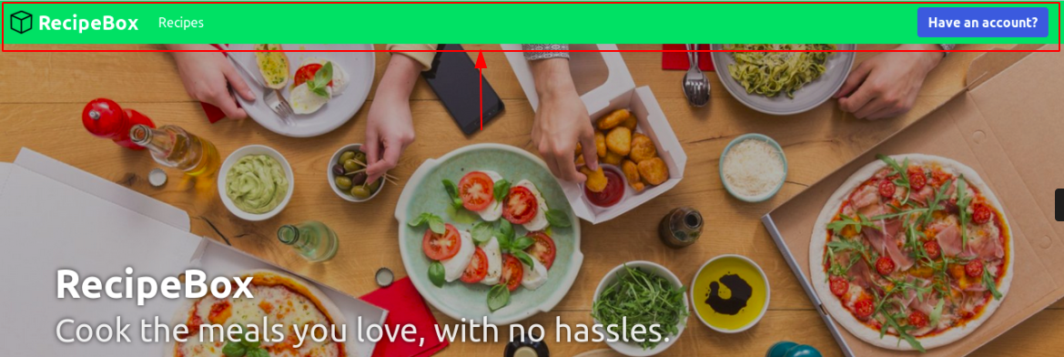

You can view the meal boxes we offer when clicking the **Recipes** item.

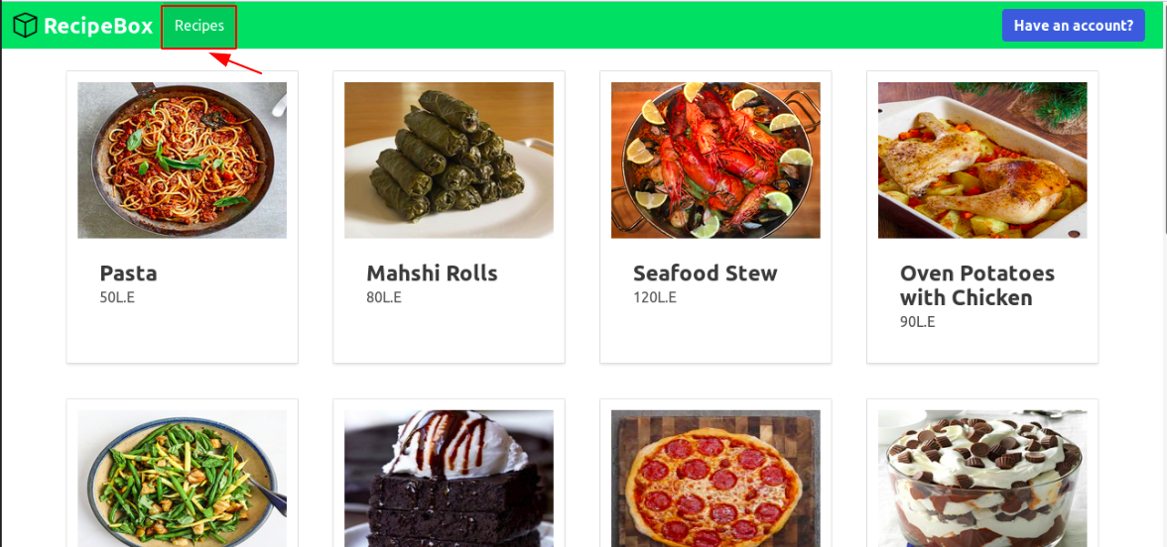

You can get a more detailed view of each recipe by clicking on it.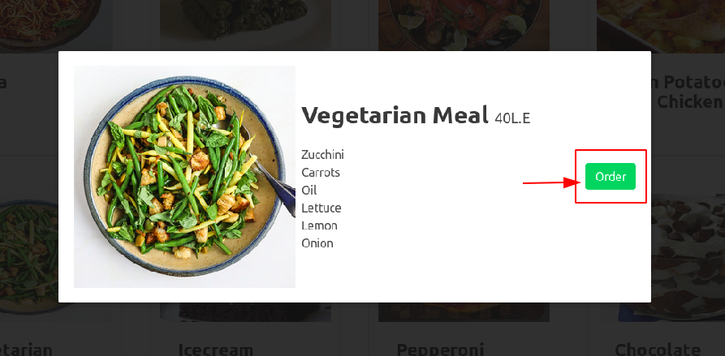

However if you’d like to order a meal box, you need to login to your account.

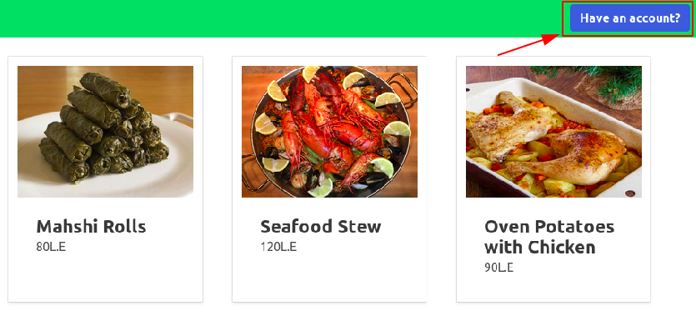

|  |  |
| --- | --- |
|  |  |

Immediately, you can confirm that you are logged in by having your email address shown at the top right corner, you can also log out using the **Log out** button

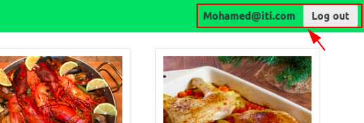

Now if you order, you’ll be alerted that your meal will be shipped to your address within 2 hours.

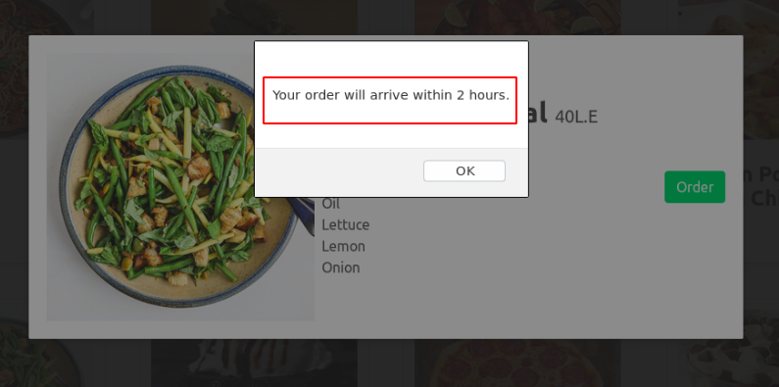

For website **Admins**, when they are logged into their accounts, they are able to view more options that the regular user can’t, such as the pages for adding new recipes, ingredients, and reviewing user orders.

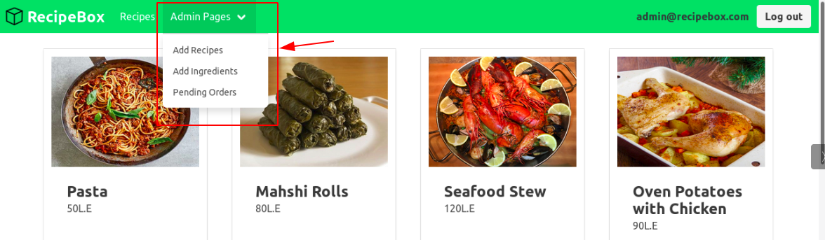

For adding recipes, the following information about the recipe must be filled.

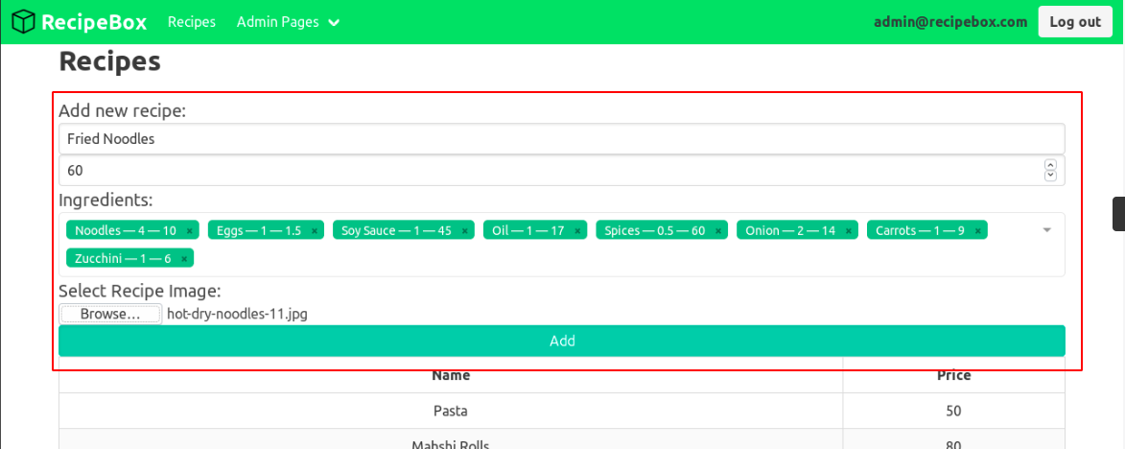

Upon adding the recipe, You’ll find it immediately added to the existing recipes list.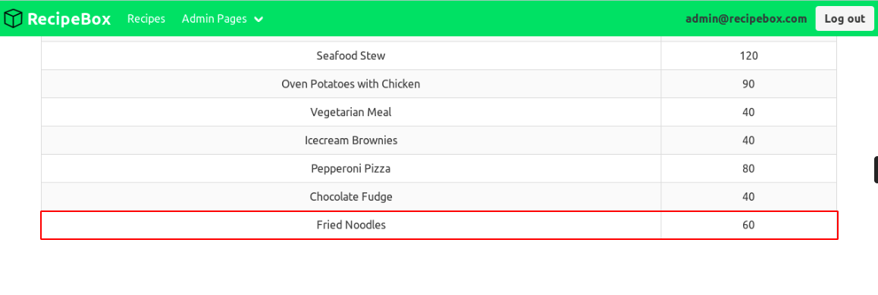And if you navigate to the Recipes page, you’ll see it live, where other users can see.

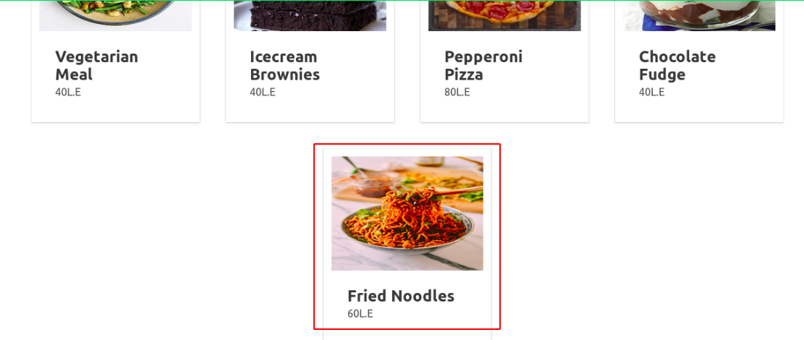

If a certain ingredient you need for a recipe is missing, you can add it from the “**Add Ingredients**” page.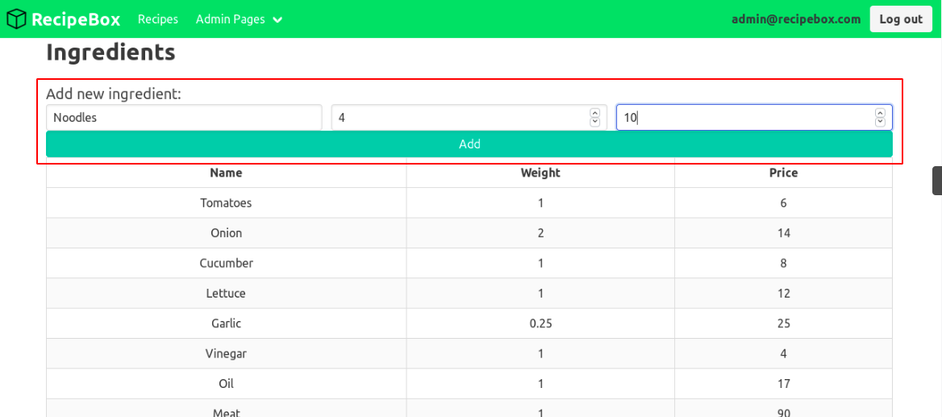

After filling the ingredient’s information, you’ll have it added to the existing ingredients list immediately.

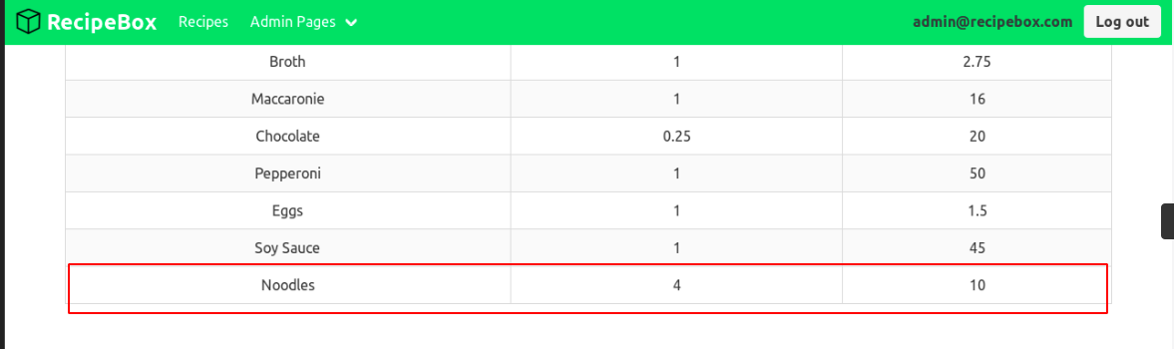

You can also view the orders placed by users in the “**Pending Orders**” page.

